**Daniel Williamson**

**Project #2**

**2/19/16**

**CS 200**

Project Overview

Purpose:

The purpose of this project was to simply create a circuit that can use the 7-Segment Display and count from 0 to 9 and repeat as many times as necessary.

Approach:

To begin this project I once again started with a truth table to depict our needed values for each segment of the 7-Segment Display. Once the truth table was completed I was able to create the needed K-maps for each segment. With each K-map I was then able to make a Boolean function for each and every segment. And once I had those Boolean functions I was finally able to create a circuit for each which I then converted into a sub-circuit. Last, but not least, I needed to make a clock using J/K flip-flops to flip through different inputs to count.

Results

These are my results:

This is the depiction of my Truth Table:

I needed to make this first to understand when a certain segment should be lit-up with each input.

|  |  |  |  |  |  |  |  |  |
| --- | --- | --- | --- | --- | --- | --- | --- | --- |
|  | DCBA | TR | T | TL | M | BL | B | BR |
| 0 | 0000 | X | X | X |  | X | X | X |
| 1 | 0001 | X |  |  |  |  |  | X |
| 2 | 0010 | X | X |  | X | X | X |  |
| 3 | 0011 | X | X |  | X |  | X | X |
| 4 | 0100 | X |  | X | X |  |  | X |
| 5 | 0101 |  | X | X | X |  | X | X |
| 6 | 0110 |  | X | X | X | X | X | X |
| 7 | 0111 | X | X |  |  |  |  | X |
| 8 | 1000 | X | X | X | X | X | X | X |
| 9 | 1001 | X | X | X | X |  |  | X |

This is my depiction of my K-map and Boolean function for the Top Right Segment:

|  |  |  |  |  |  |
| --- | --- | --- | --- | --- | --- |
| K-Map for Top Right | | | | | |
| F(A,B,C,D) = D’C’ + D’B’A’ + D’BA + DC’B’ | | | | | |
|  | AB | | | | |
| DC |  | 00 | 01 | 11 | 10 |
| 00 | 1 | 1 | 1 | 1 |
| 01 | 1 |  | 1 |  |
| 11 |  |  |  |  |
| 10 | 1 | 1 |  |  |

This is my depiction of my circuit for the Top Right Segment:

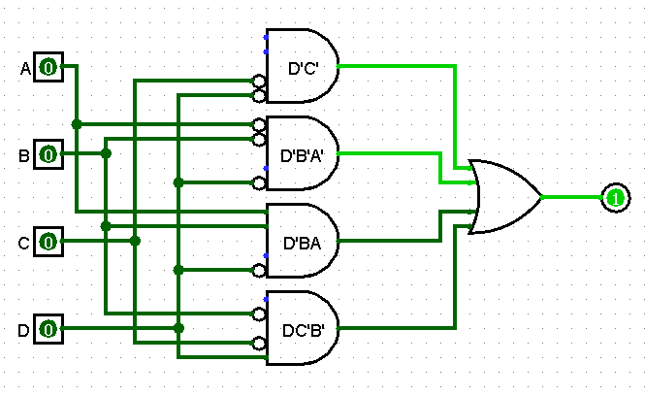

This is my depiction of my K-map and Boolean function for the Top Segment:

|  |  |  |  |  |  |
| --- | --- | --- | --- | --- | --- |
| K-Map for Top | | | | | |
| F(A,B,C,D) = D’C’A’ + D’B + D’CA + DC’B’ | | | | | |
|  | AB | | | | |
| DC |  | 00 | 01 | 11 | 10 |
| 00 | 1 |  | 1 | 1 |
| 01 |  | 1 | 1 | 1 |
| 11 |  |  |  |  |
| 10 | 1 | 1 |  |  |

This is my depiction of my circuit for the Top Segment:

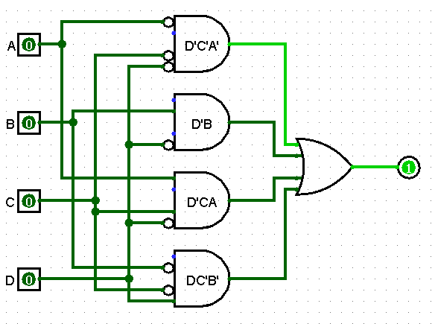

This is my depiction of my K-map and Boolean function for the Top Left Segment:

|  |  |  |  |  |  |
| --- | --- | --- | --- | --- | --- |
| K-Map for Top Left | | | | | |
| F(A,B,C,D) = D’B’A’ + D’CB’ + D’CA’ + DC’B’ | | | | | |
|  | AB | | | | |
| DC |  | 00 | 01 | 11 | 10 |
| 00 | 1 |  |  |  |
| 01 | 1 | 1 |  | 1 |
| 11 |  |  |  |  |
| 10 | 1 | 1 |  |  |

This is my depiction of my circuit for the Top Left Segment:

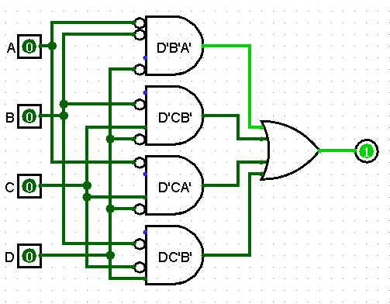

This is my depiction of my K-map and Boolean function for the Middle Segment:

|  |  |  |  |  |  |
| --- | --- | --- | --- | --- | --- |
| K-Map for Middle | | | | | |
| F(A,B,C,D) = D’C’B + D’BA’ + D’CB’ + DC’B’ | | | | | |
|  | AB | | | | |
| DC |  | 00 | 01 | 11 | 10 |
| 00 |  |  | 1 | 1 |
| 01 | 1 | 1 |  | 1 |
| 11 |  |  |  |  |
| 10 | 1 | 1 |  |  |

This is my depiction of my circuit for the Middle Segment:

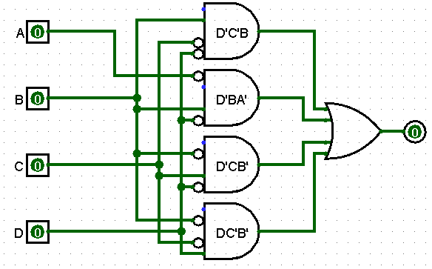

This is my depiction of my K-map and Boolean function for the Bottom Left Segment:

|  |  |  |  |  |  |
| --- | --- | --- | --- | --- | --- |
| K-Map for Bottom Left | | | | | |
| F(A,B,C,D) = D’BA’ + C’B’A’ | | | | | |
|  | AB | | | | |
| DC |  | 00 | 01 | 11 | 10 |
| 00 | 1 |  |  | 1 |
| 01 |  |  |  | 1 |
| 11 |  |  |  |  |
| 10 | 1 |  |  |  |

This is my depiction of my circuit for the Bottom Left Segment:

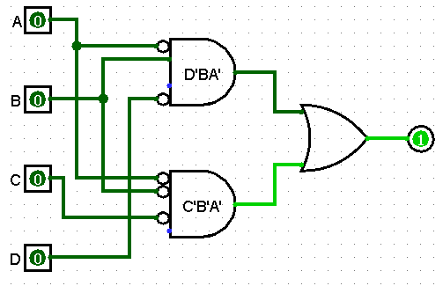

This is my depiction of my K-map and Boolean function for the Bottom Segment:

|  |  |  |  |  |  |
| --- | --- | --- | --- | --- | --- |
| K-Map for Bottom | | | | | |
| F(A,B,C,D) = C’B’A’ + D’CA + D’C’B | | | | | |
|  | AB | | | | |
| DC |  | 00 | 01 | 11 | 10 |
| 00 | 1 |  | 1 | 1 |
| 01 |  | 1 |  | 1 |
| 11 |  |  |  |  |
| 10 | 1 |  |  |  |

This is my depiction of my circuit for the Bottom Segment:

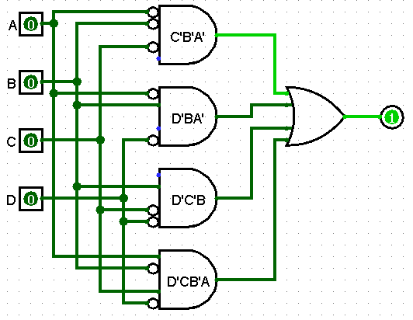

This is my depiction of my K-map and Boolean function for the Bottom Right Segment:

|  |  |  |  |  |  |
| --- | --- | --- | --- | --- | --- |
| K-Map for Bottom Right | | | | | |
| F(A,B,C,D) = C’B’ + D’C + D’BA | | | | | |
|  | AB | | | | |
| DC |  | 00 | 01 | 11 | 10 |
| 00 | 1 | 1 | 1 |  |
| 01 | 1 | 1 | 1 | 1 |
| 11 |  |  |  |  |
| 10 | 1 | 1 |  |  |

This is my depiction of my circuit for the Bottom Right Segment:

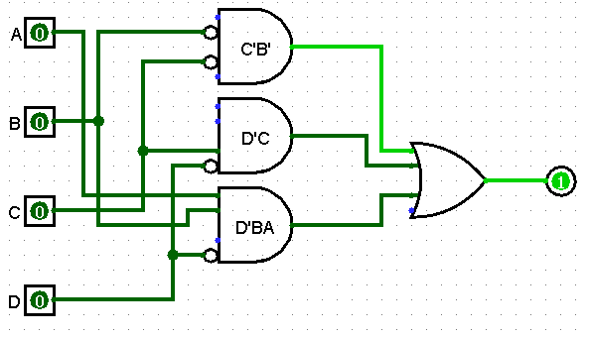

This is my depiction of my circuit for the clock:

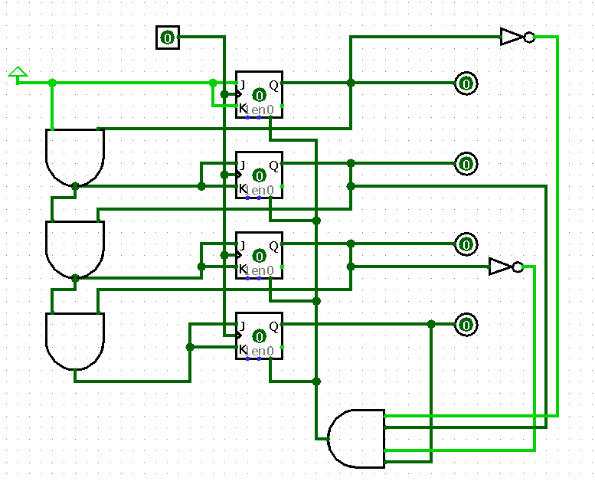

And lastly this is my depiction of the final product after making each segment into a sub-circuit and including the clock and a bottom.

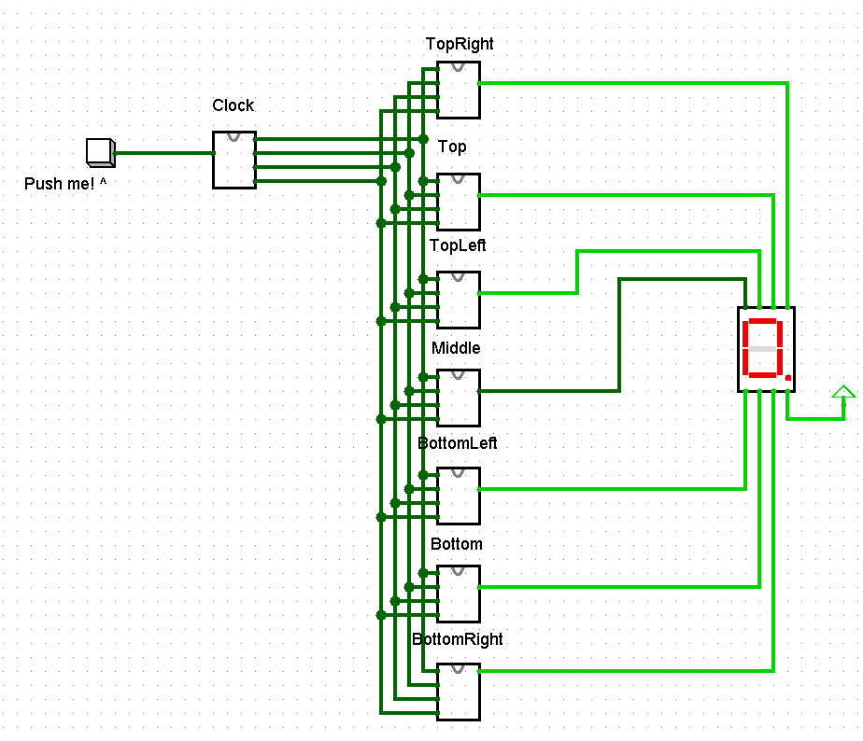

After completion of my seven segments I was able to test each and every one and would regular compare them to the K-maps I created.

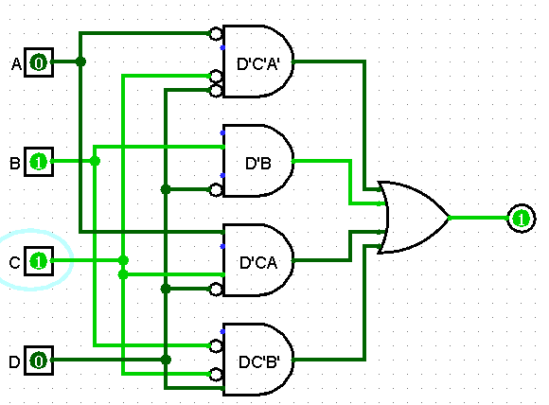

According to the Top segment k-map if your input was 0110 your output should be a 1. Which it is.

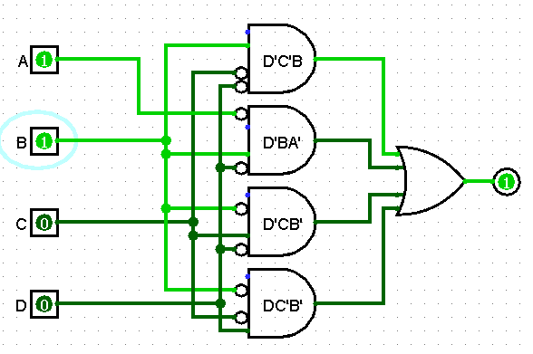

According to the Middle segment k-map if your input is 1100 your output should be a 1. Which it is.

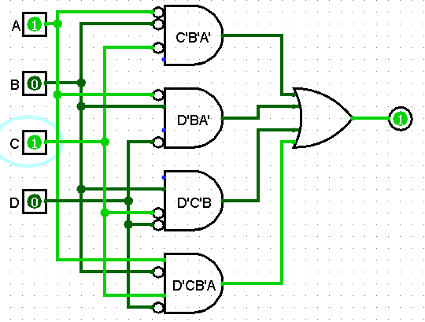

According to the Bottom segment k-map if your input is 101 your output should be a 1. Which it is.

And it was the same for all other segments.

As for testing the 7-segment display, knowing that 0110 should be a numerical value of 6. We can clearly see the display, displaying a 6.

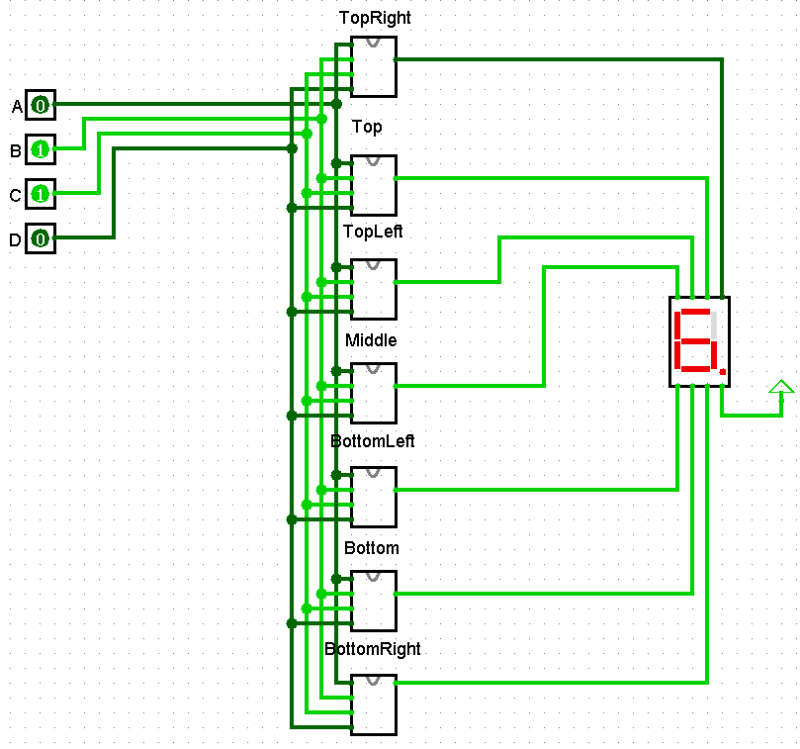

Conclusion

In conclusion this was an extremely interesting and insightful project. This project taught me how important a clock could be to flip between inputs. Once again this project taught me how important using truth tables are in creating Boolean functions for eventually making the circuit. Something so simple done over, and over again can make something so complex and awesome. A few difficulties I encountered was creating the clock which I ended up having to discuss with a peer for some insight. Another issue was with the bottom right segment which I had to completely re-work the k-map in order to get it to work.